Come into the Woods
Bettendorf, IA
For Immediate Release
After many months of dedicated work by several local vendors and craftsmen, we are proud to announce that The Tangled Wood will be open for business on Monday, January 14, 2019 at 3636 Tanglewood Road in Bettendorf, IA.
The Tangled Wood is the next stage in the evolution of the beloved local bar, Governor’s. We believe the new name embraces the scale and setting of the new location as well as the communal feel we are striving to provide for the community.
Our new facility consists of almost 7,400 square feet of bar and dining spaces for food, drinks or hanging out with friends and family. Our award-winning chef has developed a menu of new and exciting dishes combined with some local favorites you’ve loved throughout the years. Our brand-new expanded bar now offers 40 of the top commercial and craft beers on tap and a variety of new cocktail recipes.
The Tangled Wood offers two private dining rooms for special occasions or corporate events complete with televisions and audio/video equipment. The Tangled Wood is great for the entire family with our 22 televisions and phone charging stations throughout the establishment.
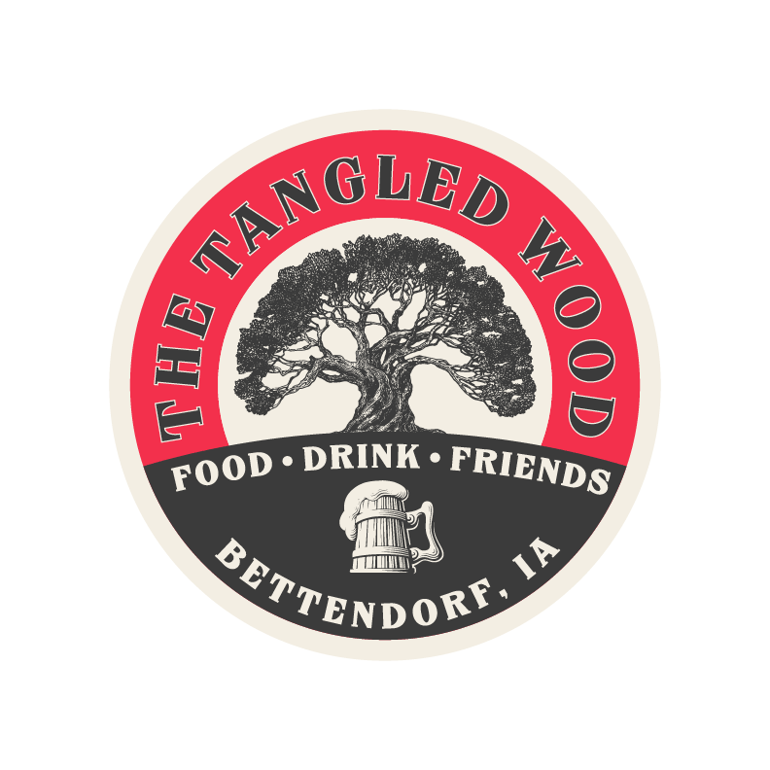
Coming in Spring of 2019 you can relax outdoors in our 8,000 square foot patio area complete with a bar, dining area, fire pits and amphitheater. Spend the day playing bocce ball, horse shoes, bags, or simply relax and enjoy a spectacular view of our wooded landscape with family and friends.
For more information about the Tangled Wood please visit our website at: www.thetangledwood.com.
Joseph Janz
Marketing Manager
info@thetangledwood.com

